Woman swears by Multiple Sclerosis remedy

Kathy Sundstrom | 25th Feb 2015 8:40 AM
IT IS expensive and controversial and the medical community is still divided about its success, but Jenni Saunders is living proof Russia's controversial stem cell treatment program can work.
The Kawana Island resident spent 30 days in Moscow in December receiving stem cell treatment she hoped would help provide some relief from the multiple sclerosis that has been slowly crippling her body for 30 years.
It has been 10 weeks since Ms Saunders' return and she is ecstatic with the results.
The 60-year-old can literally jump for joy.
It's been "years" since Ms Saunders was able to lift both feet off the ground, so the small leap in the air is a giant leap for her.
"I have seen several improvements in the last nine to 10 weeks," she said.
"The pins and needles in my hands and feet are virtually gone and I can stand up with my eyes closed.
"This might not sound like a lot to many people, but to me it is significant."
She says she is the oldest Australian to have attempted the $60,000 treatment, excluding the cost of flights.
The stem cell treatment is not approved for MS sufferers in Australia and people like Ms Saunders have to raise money to pay for the trip, even though it is available in other parts of the world.
"I'm still paying it off, but I don't care," she said.
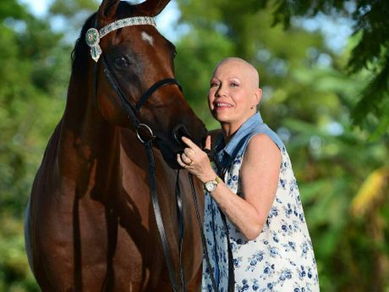
RESULT: MS sufferer Jenni Saunders has returned from specialist MS treatment in Moscow and is hoping to return to horse riding.Iain Curry
"I have had a huge improvement in fatigue. In a few years I would have been in a wheelchair, this has given me a chance.
"In Canada it is freely available to their residents and the United Kingdom is looking at putting it on the PBS.''
Ms Saunders said the Moscow clinic had a waiting list to 2017.
She said seven other Australians received treatment in December.
MS Queensland CEO Lincoln Hopper said he was encouraged by the potential that stem cell treatments offer people with MS.
"However, it is important to understand that Autologous Hematopoietic Stem Cell Transplant Treatment (HSCT) is not a treatment for everyone," he said.
"HSCT appears to be most likely to work in those with aggressive, highly active forms of relapsing remitting MS, or for those who do not respond to currently available treatments.
"The benefits for secondary progressive and primary progressive MS are much less clear at this stage and we need to better understand the risk and benefits of HSCT for these groups.
"MS Queensland knows of a number of people living with MS who are planning to undertake HSCT in Russia. We deeply respect their personal decision to do this.
"We want people considering this treatment to understand it, to know what it involves and most importantly to discuss their personal treatment options with their neurologist.
"In Australia, some 40 people with MS have received HSCT in the form of bone marrow transplants to treat active, highly aggressive cases of MS.
"The outcomes have been mixed and HSCT bone marrow treatment is still considered experimental by the Multiple Sclerosis International Federation and the wider international research community."

